# How to import a save file

Find the saved_games folder

C:\Users\enter your user\AppData\Roaming\Carrier Command 2

Or if that doesn't work you can manually navigate to the folder. To find your game's save file first head into your appdata's folder. You can do this by doing (windows key + R) then entering %appdata%

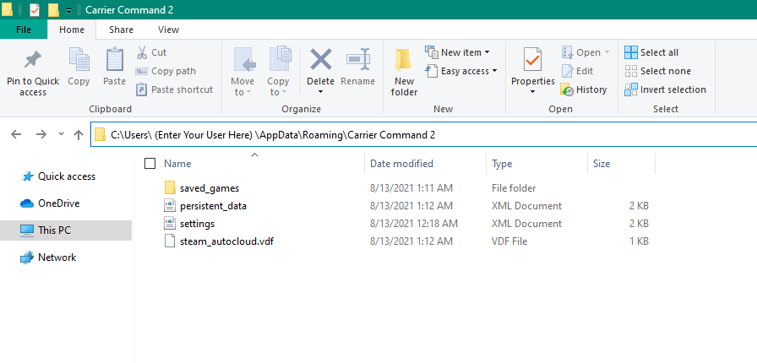

If you're the recipient of the file you want to open the saved_games folder and create a new folder and give it a name.Paste the XML save file into the folder you created.

Then head back to the persistent_data XML file. Pick any slot that's empty and fill in the time with 1. For display_name enter the name you want displayed on the load screen. For save_name enter the name of the folder with the save file. Make sure to save before exiting the file.

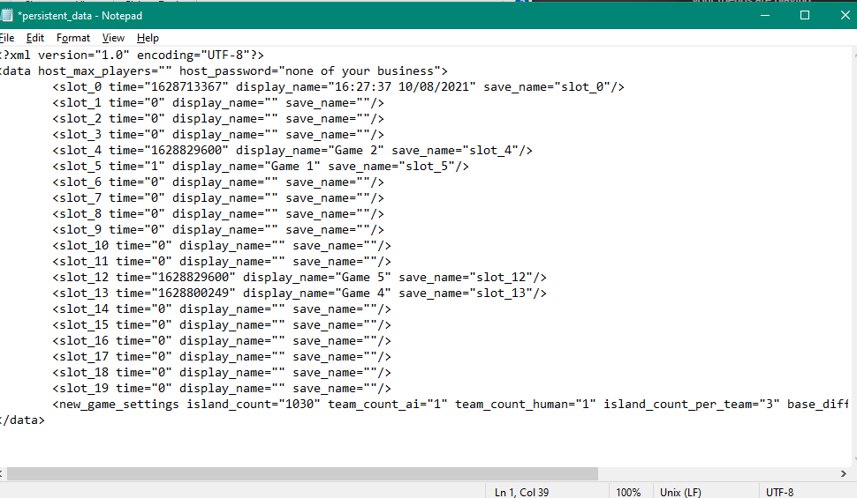

# Map info

Map 1 is set up for the host to be the streaming team. (pink team)

The team islands have no defences and there is one AI team set in the middle.

The AI team will shoot at the streaming team so be aware when flying near the middle.

Team 1 is set up to be an observer only. They are set up with mantas and fuel tanks for longer flights.

Teams 2 and 3 are set up with basic loadouts with 3k starting credits to start logistics.

Map 1 (host streaming)

* TEAM 1 (HOST)
  + Pink team set as streaming
  + Pink colored vechs
* TEAM 2
  + PVP team Gold
  + Green Camo vechs
* TEAM 3
  + PVP team Blue
  + Blue Camo vechs

# Map layout